**BOMBO PARENTS NURSERY AND PRIMARY SHOOL**

**END OF TERM I EXAMINATION 2024**

**Age Group (5 – 6 years): TOP CLASS**

**Learning Area 1: Social Development**

My name is __________________________________________

1. **Oral.**
2. How are you?
3. Go and open the door.
4. Put a pencil in the tin.
5. Do you have hands?
6. Show me your hands.
7. Clap your hands.
8. Hands for .....................
9. Do you like your hands?
10. Show me your teeth.
11. What do we use to clean our nose?
12. Show me you nose.
13. Show me your tongue.
14. What is the colour of your tongue?
15. Count your fingers.
16. **Join the dots and copy the word.**

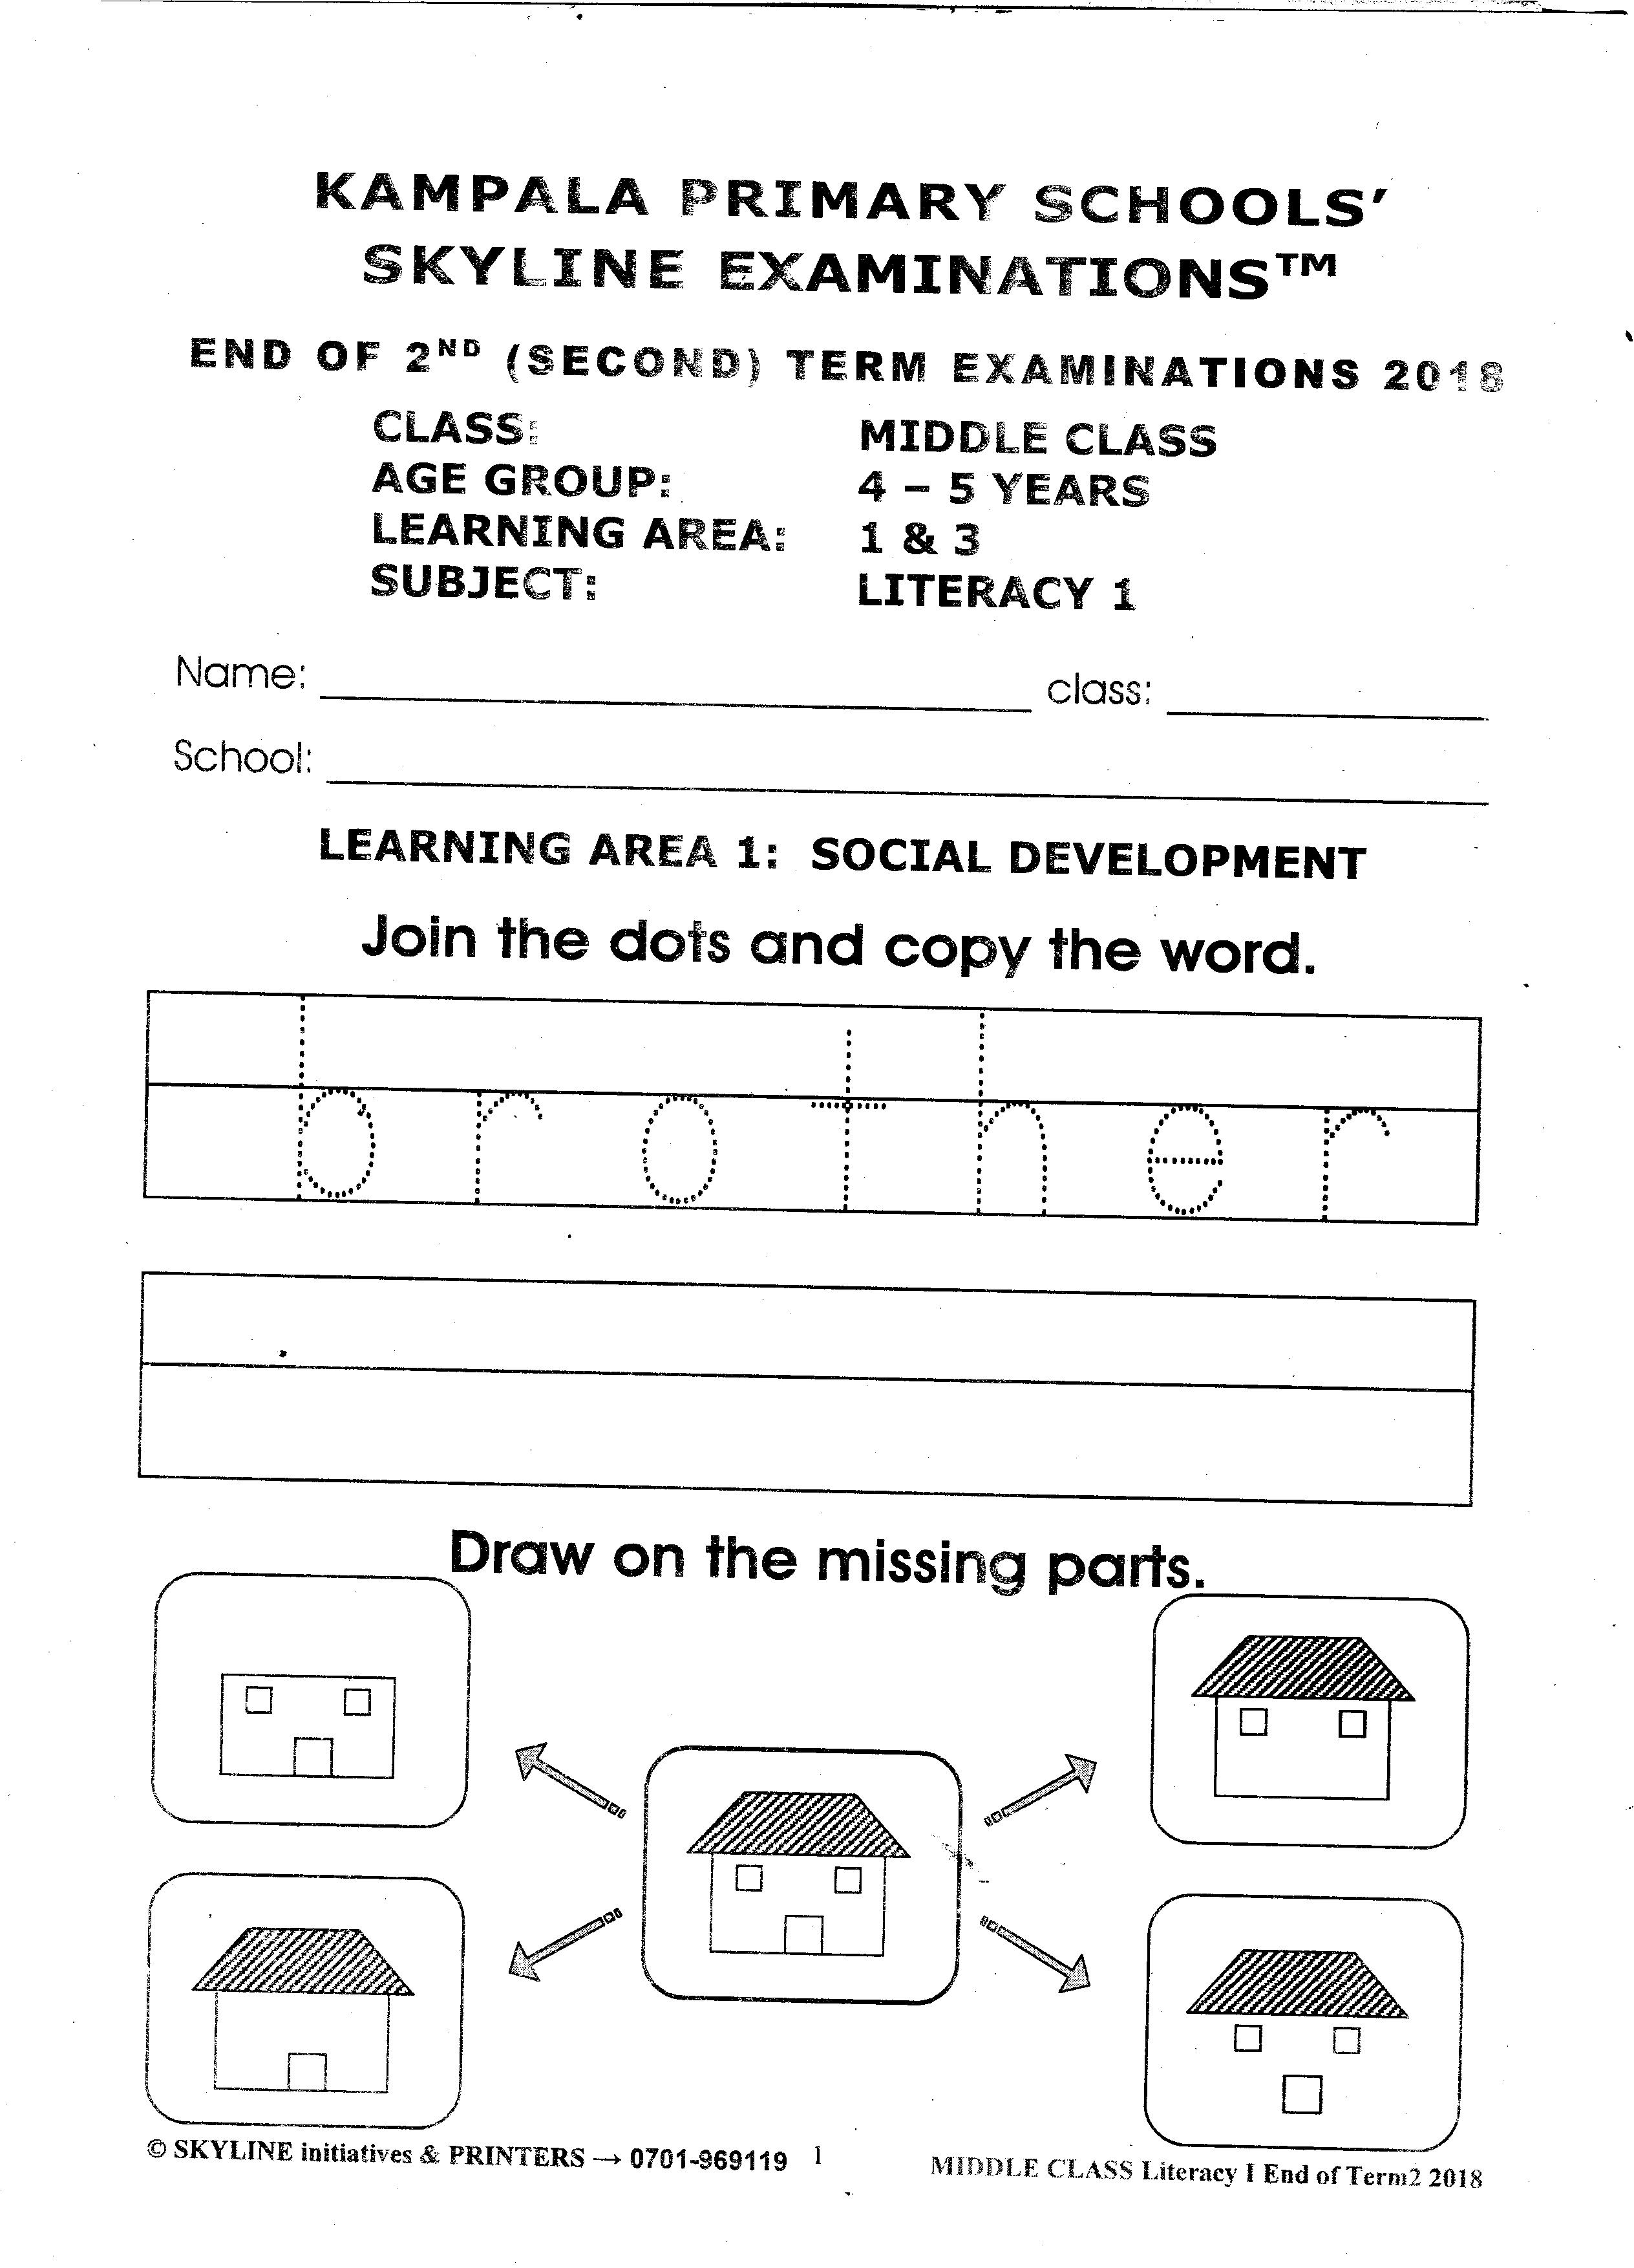

1. **Draw on the missing parts.**

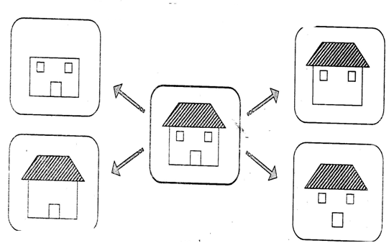

1. **Join the dots and make a word.**

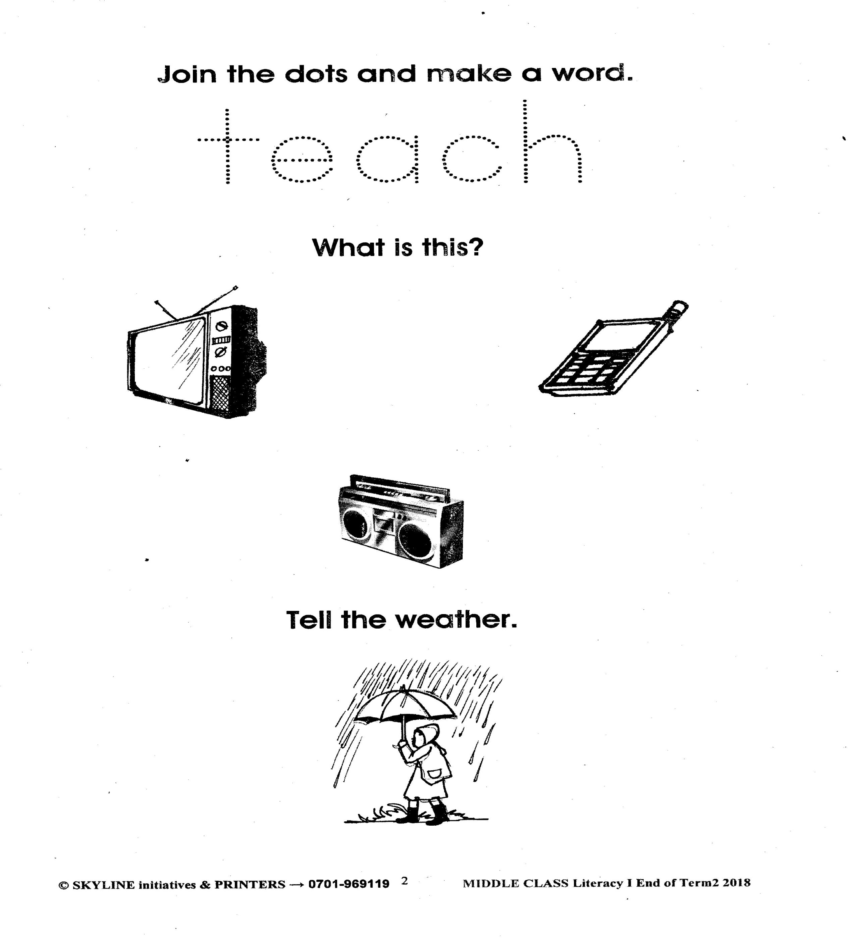

1. **What is this?**

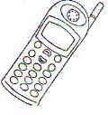

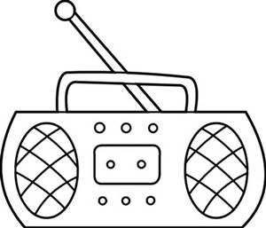

1. **Tell the weather.**



1. **Draw a broom.**
2. 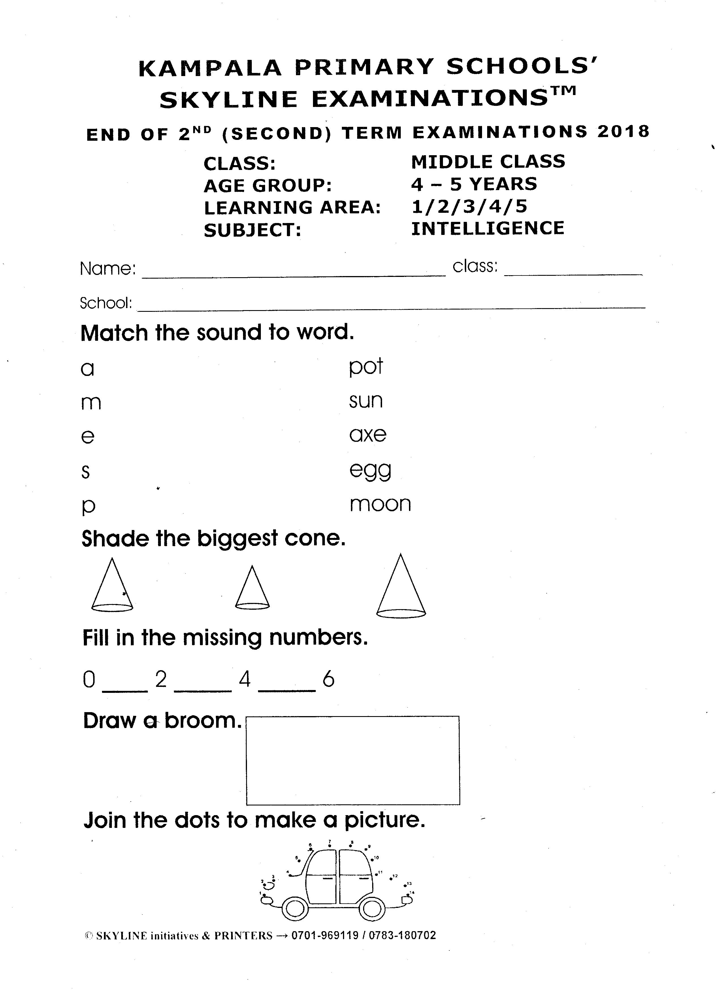**Join the dots to make a picture.**

**End**